**CISC 205**

**OOP Using C++**

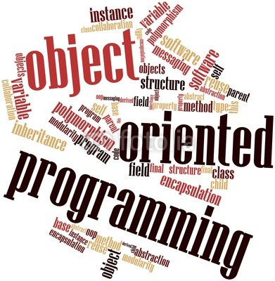

**Professor Larry Forman**

**Fall Y2K14**

**T TH: 9:35 am – 12:45 pm BT-211 Lecture + Lab**

** SYLLABUS -- CISC 205: OOPC++**

**= = = = = = = = = = = = = = = = = = = =**

**OOPC++ OOPC++ OOPC++ OOPC++**

Professor Larry Forman, San Diego City College

Telephone: (619) 388-3666 (24-hour HOTLINE) / Lab 388-3770

 Fax: 388-3063

E-Mail: **LForman@sdccd.edu** **– best** **way to reach me!**

Mail Box: Room A-8

Office: Room BT-210-G

"Office" Hours: Before & after class in the Lab and on-request

Great time for a study session with me!

**COURSE**

 Computer & Information Sciences 205: Object Oriented Programming using C++

**MEETINGS**

16 weeks of "lecture" and lab. Also, special field trips may be arranged

**CATALOG COURSE DESCRIPTION**

This course introduces students to Object Oriented Programming (OOP) using the C++ programming language. Emphasis is placed on essential concepts related to OOP, including use of classes and objects, inheritance, templates, polymorphism, pointers and references, and input/output (I/O) streams. This course is intended for students majoring in computer information technology and all students interested in OOP. Associate Degree Credit and transfer to CSU UC Transfer Course List.



**PREREQUISITES (ADVISORY)**

CISC 192 with a grade of “C” or better, or equivalent**!!!**

**OBJECTIVES**

"Reason is the slow & tortuous method by which those who do not know the truth discover it."

Blaise Pascal (1623 - 1662)

"Inch by inch, life's a cinch. Yard by yard, life is hard."

Provide an introduction to the FUN-damentals of the most dominant cornerstone of 21st century computer science: object-oriented programming. Using one of the most widespread programming languages in the world, C++, we will enjoy hands-on experience designing, writing, coding, debugging, testing, documenting and demonstrating programs in C++ on Windows-based or compatible computers. Learn professional programming techniques and the power of object-oriented programming.

Discover the excitement and challenge of developing your own interactive multimedia computer programs that combine text, graphics and audio for stand-alone applications. Gain competence, confidence and comfort in the magical world of object-oriented programming.

**TEXTBOOKS**

Plan to use any textbook, like **. I highly recommend all the textbooks below! Feel free to use free e-books or rent books or buy used ones. In addition, some lectures and assignments will be based on supplemental readings and handouts provided by me.

**\*\* Starting Out with C++ from Control Structures Through Objects, Gaddis, Prentice Hall, 2015**

**C++ Programming: Program Design Including Data Structures, Malik, Cengage, 2013**

**Intro to Programming with C++, Liang, Prentice Hall/Allyn, 2014**

**Programming and Problem Solving with C++, Dale & Weems, Jones and Bartlett, 2014**

**C++ Programming in Easy Steps, 4th Ed., McGrath, Computer Step, 2011**

**Free tutorials at places like:**

[**thenewboston.org/tutorials.php**](http://thenewboston.org/tutorials.php) **,** [**www.cplusplus.com**](http://www.cplusplus.com)**, etc.!**

[](http://images.google.com/imgres?imgurl=http://media.arstechnica.com/journals/thumbs.media/FlashVoyagerHeroRGB.gif&imgrefurl=http://arstechnica.com/journals/thumbs.ars/2006/12/12/6260&h=437&w=600&sz=37&hl=en&start=12&tbnid=BzAvxx9vs1qFwM:&tbnh=98&tbnw=135&prev=/images?q=flash+usb+drive&gbv=2&hl=en) **SUPPLIES**

SYLLABUS -- CISC 205 (Free at first class)

Textbooks (2) -- you pick, including rentals, free e-books or library books!

At least two different ways to store and backup your programs – I recommend USB

(flash) memory – or online storage – AND your computer's hard drive.

Materials for Portfolio and laser printouts @$0.10 per page

Supply of curiosity and perseverance sprinkled with creativity and patience;

very valuable: attention to detailz . . .

Lots of time -- the average student with average computer programming background who expects an average grade will average 8-12 hrs/week outside of class, on average!

**FREE SOFTWARE DOWNLOADS (Caution: Follow directions carefully!):**

[www.visualstudio.com/downloads/download-visual-studio-vs#d-express-windows-desktop](http://www.visualstudio.com/downloads/download-visual-studio-vs#d-express-windows-desktop) for Microsoft Visual Studio Express 2013 Express for Windows Desktop

[www.dreamspark.com](http://www.dreamspark.com) also offers students free, professional level software

**BTW: You are encouraged to bring your own laptop to class!!**



**COURSE OUTLINE**:

1 – Surfing the Visual Studio C++ Environment: Editor, Preprocessor, Compiler, Linker, Loader and Debugger

2 – Review of C++ Programming Fundamentals:

Input/Output Operations, Constants, Variables, Functions, Arithmetic Operations, Loops, Decisions, Arrays, File I/O, Sorting, “Michelangelo” Documentation

3 – Interactive Processing via Dynamic ASCII Graphics, Audio and Header Files

4 – Pointing the Way with Pointers

5 – Overview of Object-Oriented Design Fundamentals

6 – Doing it with Classes

7 – Constructors, Destructors and Overloading

8 – Inheritance and Polymorphism

9 – Virtual Functions

10 – Exceptions, Templates and the Standard Template Library

11 – The Curse of Recursion . . . Recursion . . . Recursion

12 – Future Directions in Object-Oriented Programming

**COURSE SCHEDULE**

Due-dates of assignments will be announced in class. All assignments will be accepted and given full credit, only if turned in on time. **The default grade is ZERO for assignments not turned in on time.**

NOTE: Happy News . . . Final Exam is: **Tuesday, December 16, 2014**

PS: We have holidays on **Tuesday, November 11 AND Thanksgiving Week, November 24 - 28** And Field Trip(s) on: **TBA**

**GRADES/LEARNING**

Points

**25** 20 - Grande Finale Project and Presentation

**50** 35 - 4 Program Projects (**40** 30 Points) and 10 Training Assignments (**10** 5 Points):

Demo with Correctness, Modularity, Output Aesthetics & User Friendliness, Comprehensive Testing, Efficiency and Michelangelo Documentation

**WARNING: Demos may occur during “office hours” outside of class sessions**

20 - **30 STAR**s (**S**omething **T**errific **A**nd **R**evolutionary)

These are extensions of regular assignments -- like extra-credit. Except required. Throughout the semester you will have hundreds of opportunities. Just pick 30.

As a bonus, each STAR over 30 counts an additional 1-Point of the course grade if you achieve > 10 (out of 20) points on the Grande Finale Project and Presentation – otherwise each STAR above 30 counts as ½-Point.

**0** 20 - Quizzes (minus 2 lowest) -- open-book and often with re-tries. NOTE: If you are

absent for a quiz, the grade is zero, unless it is an excused absence at which point you can request a makeup quiz at the next class, otherwise the grade remains zero

5 - Final Exam -- includes **submitting a CD** or flash-drive of EVERY class assignment, program AND digital handout along with your hardcopy Portfolio of all Programs, Training Assignments, Handouts, Class Notes and Green Grade Sheets. Use 3-Ring Binder, Cover Page, Table of Contents, Divider Tabs with titles, Section Pages, Documented Program Listings and Sample Screen Output

**TIMES** Midterm (Course Feedback/Portfolio-in-progress)

**-----** **TIMES** Attendance **– More than ONE unexcused absence 🡺 Loss of 5 points**

100 -- Course Grade = Total Number of Points times Q, where Q = **1.0** **NOW** if Quiz

average >85, Q = .95 if Quiz average 80-85, Q = .90 if Quiz average <80 with

Course Grade of: A = 90-100, B = 80-89, C = 70-79, D = 60-69, F = <60



**ATTENDANCE**

We will have a moment of silence for anyone absent from class. But, you are responsible for ALL work, announcements and assignments given during your absence. It is best to contact fellow students, not me, for details when absent. A network of student Support Teams will assist you. Their purpose is to encourage you to succeed and have fun here.

An unexcused absence (your limit is one) occurs when you as a C++ consultant miss a class and do not inform me (your client) about the absence. **Arriving late to class OR leaving class early OR not signing the attendance sheet counts as half of an unexcused absence.**  For an **EXCUSED absence,** just contact me – preferably before class, but if not, then **within 24 hours** after the start of class – with a **“professional”** email at[LForman@sdccd.edu](mailto:LForman@sdccd.edu) **or** call my office/24-hour voice mail: 619-388-3666. OR during the class you are absent have a member of your “Buddy List” email me or supply a written note about your absence. If you can’t contact me within 24 hours due to an unusual situation, then for an excused absence contact me before our next class to explain what happened.



**DROPPING OUT**

If circumstances necessitate your dropping this course, as a professional courtesy **please inform me – by email, phone or in-person – of your intention to drop.** BTW: Students are responsible for dropping their own classes and are not officially dropped until they do it themselves online. **However, I may drop you if you:**

1. Have an unexcused absence on the first day of class OR
2. Have three consecutive class sessions with unexcused absences OR
3. Have four absences of any combination of excused and/or unexcused AND before the next class session starts, do not discuss with me either in person or over the telephone the reason for the fourth absence
4. Are not making “progress” – which is “actively participating in class & handing in 80+% of work while earning at least a C- average” – in any two-week period.

**BEHAVIOR**

MCj04244700000[1]Respect the integrity of fellow students, of me and of the lab (= use technology ONLY for class-related work, NEVER download or install software and always follow proper lab “etiquette”). Students are encouraged to ask each other questions about program concepts and assignments, and help each other learn. However, the final product turned in for a grade must be completed individually. Jointly produced programs or the sharing of any parts of a program are not appropriate unless otherwise indicated by me. Copying someone’s work is NEVER acceptable. Follow the "Don't ask, don't tell" policy: Don't ask to copy someone's work and don't tell someone that it's okay to copy your work! Otherwise, offenders will be hung by their toenails and everyone in the class will “earn” a zero grade . . . for starters!



**PLEDGE**

"In teaching, I seek not to be an anchor that holds you back nor a sail that takes you there, but a guiding light that helps you find your own way . . ."

This may be the most amazing course you have ever taken! I promise that it will be one of the most rewarding and memorable (and even enjoyable) -- if you strive to participate fully and wholeheartedly in each class. I definitely will!

I have two major priorities in this course:

Priority #1: Your success is my first concern

Priority #2: Never forget Priority #1

Everyone wants success. But, only a special few actually achieve it. I pledge to help each and every one of you achieve success in this course by helping you become the best you are capable of becoming. In turn, I will count on you to help me become the best that I am capable of becoming. I love teaching and want to become the best I can. Only you can help me attain my goal.

To achieve success requires three basic ingredients: knowledge, confidence and perseverance. The most important of these is perseverance – being determined to hang in there when things get tough. Few people succeed only because they are smart. Few people succeed only because they are confident. In fact, people succeed because they dedicate their time and effort, again and again and again. They don't quit – they persevere! As the old saying goes, "Winners never quit and quitters never win." Plan on being a “winner”! And be forewarned: This is a “lake” class, not a “river” one . . .

Remember Thomas Edison: genius is 1% inspiration and 99% perspiration. By the end of this course, expect to be a genius. Expect to discover something new about yourself. Expect to grow a lot. By semester's end, your friends and loved ones may not recognize you. You will have grown taller and "older" in knowledge and understanding. You will have boldly gone where only a special group of students has ever gone before: you will have completed a course with me . . . and your life may never be the same!

To help you rise to these heights of success,

I pledge

with all my effort and dedication

to maintain my:



**Ten Commandments**

1 -- Set the highest standards possible to help you attain confidence, competence and comfort with the subject matter

2 -- Challenge you to reach beyond your grasp and stretch yourself beyond what you thought was your limit

3 -- Create an environment that encourages excellence through the "triangle" of learning

4 -- Put some fun in teaching the fun-damentals of Computer and Information Sciences

5 -- Welcome enthusiastically every question and comment

6 -- Be approachable, helpful and open to you -- both in and out of the classroom

7 -- Cultivate the 4 R's and 5 P’s of success: being resilient, relentless, resourceful and

revolutionary AND able to peruse, practice, persevere, prepare and participate

8 -- Greet you with a smile everyday

9 -- Remind you that if all else fails there is always one question you can ask:

"Professor Forman, can you help me?"

10 -- Help you maintain your own "Pledge" of expectations

Good luck and have fun in our joint pursuit of excellence in education. Together, we can unlock our potential for success and discover what we truly are capable of achieving.

I, the undersigned, have read this syllabus and Professor Forman's Pledge and will commit myself to fulfill the responsibilities of this syllabus and to help Professor Forman celebrate his Pledge. TOGETHER, WE CAN DO IT!

YOUR SIGNATURE: DATE:

===============================================================

"Education is learning what you didn't even know you didn't know."

Daniel J. Boorstin

===============================================================

**Download and install Visual C++ 2013 Express:**

[**www.visualstudio.com/downloads/download-visual-studio-vs#d-express-windows-desktop**](http://www.visualstudio.com/downloads/download-visual-studio-vs#d-express-windows-desktop)

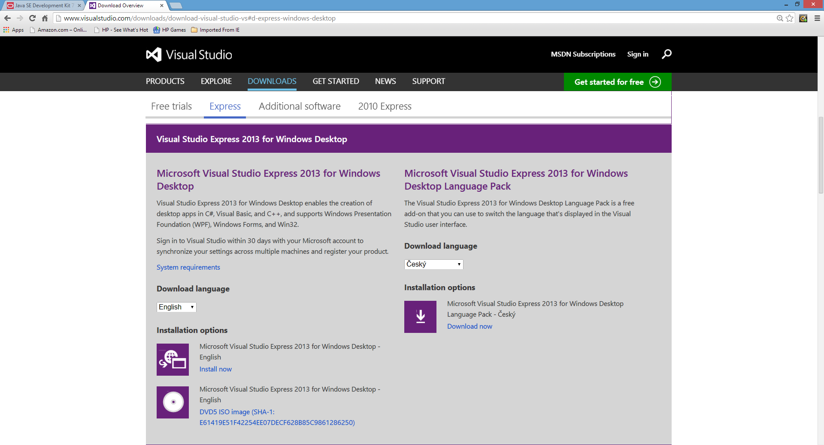

**Pay attention to the System Requirements!**

**You may need to first install Service Packs and DirectX9**

**And then after the installation also install a patch!!!**

**(After all, this is a Microsoft product . . .)**

**Select the environment you need such as**

**For Windows Desktop (for Windows 7, or 8 or ?)**

**Click on: INSTALL NOW – ENGLISH**

**(BTW, expect this installation process to take a lot of time!)**

**CISC 205 – OOP Using C++**

**HONORS CONTRACT**

**(NOTE: HONORS CONTRACTS are optional opportunities for students!)**

This is an HONORS ADDENDUM to my regular non-honors syllabus to describe the honors components of the contract.

Each student will perform the following additional assignments that will enable the student to delve more deeply into the complexities of object-oriented C++ programming. In these assignments, the student will uncover advanced concepts that are not normally introduced in my non-honors course. As a result, the students will pursue independent research, refine their critical thinking skills, perform more sophisticated analyses, undertake extensive reading of advanced programming concepts, provide a special class presentation and handout about their research findings and work on additional programming assignments.

Specifically, the student will:

1. Perform 50 STARS (Something Terrific And Really Spectacular) rather than the normally required 30 (STARS are like extra-credit, but required).
2. Design, develop and implement an additional programming project that goes beyond the basic concepts. This can be a separate project OR it can expand the Final Project by performing an additional 15 or more different STARS (beyond the 50 mentioned in A. above). An example of an extra program could be one that implements an interactive graphical user interface with advanced event-handling features or involves a database with sorting and searching features.
3. Conduct a class presentation about the aforementioned project, along with creating and distributing a handout that clarifies the advanced concepts underlying the project.

BTW: Not completing items B. and C. will reduce the course grade by 10 points.

Larry Forman, Ph.D.

Professor of Computer and Information Sciences

6l9.388.3666

[LForman@sdccd.edu](mailto:LForman@sdccd.edu)

